Patient information guide on the General Practice Data for Planning & Research service (GPDPR)

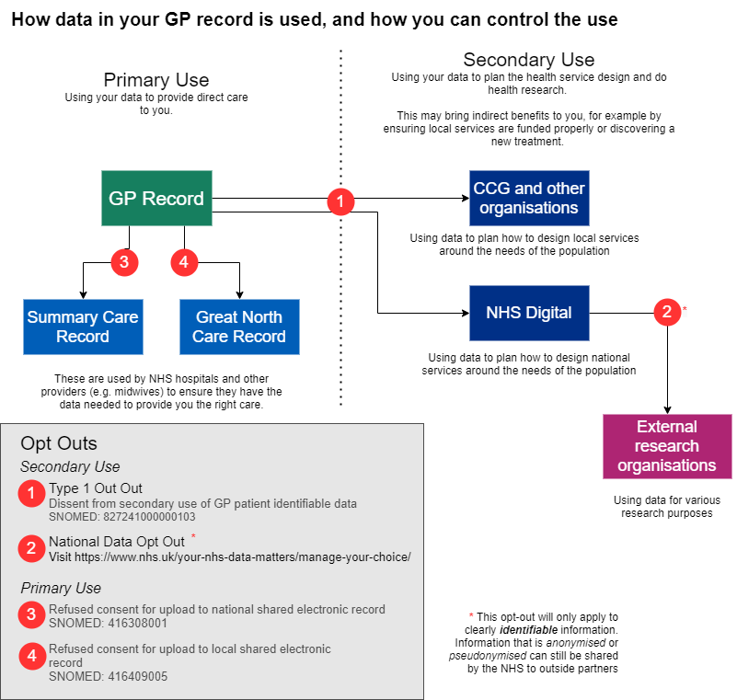

How data in your GP record is used and how you can control the use (opt-out)
As a practice, we fully respect your right as a patient to control your data. We outline our privacy policy https://www.benshamfamilypractice.nhs.uk/about-us/practice-policies/patient-record/how-we-use-your-data/privacy-policy/ in more detail on our website and explain how we share data with other providers, including the Great North Care Record and NHS Digital for secondary use.
You have the right to opt-out at any time from data being shared.
Your data is used in broadly two different ways:
- To provide you with care. This is called “Primary Use“
- To allow for planning and research to be done. This is called “Secondary Use“
Both uses will only be made where it is considered secure and appropriate to use patient data.
Opting-out of data sharing is an option for all patients, however it is not without potential downsides. For Primary Use data, if you opt-out and need care in a local hospital, for example, it may be much harder for the staff to access important medical information about you needed to provide safe and effective care. For Secondary Use, the downsides are more indirect. If everyone in the country were to opt-out, it would make it much harder to ensure funding is used in the NHS to develop services where they are needed. It would also be harder to develop new treatments.
It is possible to opt-out of specific parts of data sharing, while keeping some elements of data sharing in place. It is very common, for example, for people who have privacy concerns about Secondary Use, to be happy to continue sharing data for Primary Use/Direct Care.
The below table summarises what opt-outs are possible, and how to request them:
How data in your GP record is used, and how you can control the use
Primary Use - sharing your data for your direct care
Who it is shared with | How it is used | How to opt out
Summary Care Record | These are used by NHS hospitals and other providers (e.g. midwives) to ensure they have the data needed to provide you with the right care. | Opt out through your GP practice - contact the surgery reception to speak to the practice manager/deputy practice manager to discuss this and we will be able to apply the opt-out
Great North Care Record

Secondary Use - Using your data to design health services and do health research
Who it is shared with | How it is used | How to opt out
Local NHS Organisations (such as Clinical Commissioning Groups) | Using data to plan how to design local services around the needs of the population | Use a 'type-1 opt out' - Please send this form to the practice by emailing to ngccg.a85002@nhs.net
NHS Digital | Using data to plan and design national services around the needs of the population
External research organisations | Using data for various research purposes | Use the National Data Opt-out – Visit the NHS website, use the NHS App or call 0300 3035678

How to manage your sharing preferences using the NHS App
You can view or change your current preference at any time.
To view and change your preference in the NHS App:
1. Go to Your health
2. Select Choose if data from your health and care records is shared for planning and research.
3. Select Make your choice.
4. Review the information on the page, then select Start now.
5. View your preference, then select Change if you want to change it.
6. Update your choice, then select Submit.
You can also visit www.nhs.uk/your-nhs-data-matters.

